AUTOMATIC SEGMENTATION OF THE PULMONARY LOBES FROM CHEST CT SCANS BASED ON FISSURES, VESSELS, AND BRONCHI

ABSTRACT
In image processing the segmentation of image is a major task. The segmentation is related to clinical practice and challenging for cases severe diseases or incomplete fissures. First we are going to detect the foreground and background of the image. After that the automated segmentation method is used to segment the lungs. This automated segmentation method is called as Marker based watershed transformation. In this transformation the lungs divided into lobes. The lung image contains fissure, vessels and bronchi. From this segmentation result we are going to calculate the distance between the incomplete fissures.
Further we draw graph from this result, this graph contains the distance between the complete fissures result. This segmentation can be analyzed by the integration of several anatomical structures is against misfissures or incomplete fissures. For evaluation the method was compared to a recently published method on 20 CT scans with no or mild disease. Finally, we analyze the relation between segment quality and incomplete fissure it shows the robust against incomplete fissures.

INTRODUCTION
IMAGE PROCESSING
Image processing is a method to convert an image into digital form and perform some operations on it, in order to get an enhanced image or to extract some useful information from it. It is a type of signal dispensation in which input is image, like video frame or photograph and output may be image or characteristics associated with that image. Usually Image Processing system includes treating images as two dimensional signals while applying already set signal processing methods to them. It is among rapidly growing technologies today, with its applications in various aspects of a business. Image Processing forms core research area within engineering and computer science disciplines too.
Image processing basically includes the following three steps. Importing the image with the optical scanner or by digital photography. Analyzing and manipulating the image which includes data compression and image enhancement and spotting patterns that are not to human eyes like satellite photographs. Output is the last stage in which result can be altered image or report that is based on image analysis. The two types of methods used for Image Processing are Analog and Digital Image Processing. Analog or visual techniques of image processing can be used for the hard copies like printouts and photographs.
Image analysts use various fundamentals of interpretation while using these visual techniques. The image processing is not just confined to area that has to be studied but on knowledge of analyst. Association is another important tool in image processing through visual techniques. So analysts apply a combination of personal knowledge and collateral data to image processing. Digital Processing techniques help in manipulation of the digital images by using computers. As raw data from imaging sensors from satellite platform contains deficiencies. .
To get over such flaws and to get originality of information, it has to undergo various phases of processing. The three general phases that all types of data have to undergo while using digital technique are Pre- processing, enhancement and display, information extraction. Before going to processing an image, it is converted into a digital form. Digitization includes sampling of image and quantization of sampled values. After converting the image into bit information, processing is performed. This processing technique may be Image enhancement, Image restoration, and Image compression.
FISSURE SEGMENTATION
The clinical practice of thoracic surgery requires the surgeon to have intimate knowledge of pulmonary anatomy and of its variations. Attempts to perform thoracic procedures without this knowledge can only result in incomplete operations or technical mishaps. Proper understanding of the anatomy of the pulmonary lobes, segments, and fissures allows the surgeon to correlate imaging, pathologic processes, and possible resection procedures, thus insuring that each patient gets the best possible operation. The right lung has 3 lobes and two fissures. The Lobes are Right Upper Lobe (RUL),Right Middle Lobe (RML),Right Lower Lobe (RLL).The Fissures are Major Fissure (aka oblique fissure),minor fissure (horizontal fissure). The lobes of the lung are further divided into segments.
If you are a high achiever, you could learn the segments of the lobes. This can be useful when interpreting consolidation patterns on plain film chest X-ray images- involvement of different segments of a lobe will produce different patterns of consolidation. The horizontal fissure of the right lung is the only lung fissure that is normally demonstrated on a PA/AP chest plain film image. The horizontal fissure is evident on PA CXR in about 45% of cases. The right oblique fissure is more oblique that the left- the left oblique fissure is more vertical probably due to the mass of the heart on the left. The right and left oblique fissures are somewhat variable in their position. The right oblique fissure can sometimes be positively identified on the lateral image by the horizontal fissure which will stop at the right oblique fissure.
The example above demonstrates a pathology (RML collapse) causing the horizontal fissure to be hidden on the PA view. The reverse is also true- pathology can reveal a lung fissure that is normally hidden. This is a patient with RLL collapse. The PA view demonstrates what looks like a depressed horizontal fissure (arrowed). The lateral image reveals that this is in fact the oblique fissure which has been pulled into an abnormal position by the RLL collapse. The lung fissures are commonly demonstrated graphically as lines. They are in fact a more complex shape and could be drawn more accurately as slightly propeller shaped. May occasionally appear as two lines reflecting curve/step-off. The right middle lobe has two pulmonary segments which are situated side by side; the more lateral segment approximates the size of its adjacent neighbor (medial segment). The medial segment abuts the right heart border medially, while lateral segment extends to and comprises a portion of the lateral border of the right lung.
LUNG LOBE SEGMENTATION
Lung anatomy includes the lung parenchyma, which carries part of the conduction system but is mainly involved in the gas exchange at the alveolar level. The lung parenchyma is further subdivided into lobes and segments. The lobes are characterized by a discrete connection with the first subdivision of the bronchial tree after the level of the principal bronchi to both lungs - these are the lobar bronchi. In a similar manner, the vascular, nerve and lymphatic supply from the hila to each lobe has minimal connection with other lobes. This makes the lobes relatively independent functional units within the lung.
Indeed, pathology may be confined to one lobe and corrective surgery may be facilitated by the clear demarcation between lobes produced by the fissures. Further, the lobes are subdivided into bronchi pulmonary segments which are volumes of lung with an organized arrangement relative to each other within a lobe and similar functional independence as the lobes. With further subdivision of bronchi, each segment is divided into secondary lobules. The right upper lobe of the lung is one of the three lobes the right lung is composed of. It consists of three segments: the apical, the posterior, and the anterior.
Branches of arteries and veins, which stem from the thoracic branch, nourish the lobes of the right lung and these, in turn, stem from the descending aorta. The left lower lobe bronchus (secondary) is one of the air passage ways into the lungs. The left lower lobe of the lung has the superior, anteromedial basal, lateral basal and posterior basal. Branches of arteries and veins that stem from the thoracic branch supply the lobes of the left lung, and these, in turn, stem from the descending aorta. The left upper lobe of the lung has a superior division, which consists of the apical-posterior segment and the anterior segment, and an inferior (lingular) division, which contains the superior and inferior segments.
Branches of arteries and veins that stem from the thoracic branch supply the lobes of the left lung, and these, in turn, stem from the descending aorta. The right lower lobe of the lung is one of the three lobes that compose the right lung. It has superior, medial basal, anterior basal, lateral basal, and a posterior basal segments. Branches of arteries and veins, which stem from the thoracic branch, nourish the lobes of the right lung and these, in turn, stem from the descending aorta.

METHODOLOGIES
The automatic segmentation method is used to segment the lung lobes. In this method, we use Marker based water shed Transformation technique. A lobe segmentation method is developed which combines anatomical information from the lungs, vessels, airways, and lobar fissures to obtain the lobes using a watershed-based segmentation method. After that perform the distance calculation between the incomplete fissures. And finally we construct a one graph for this segmentation process which contains the information about incomplete and complete fissure distance. It provides the accurate results.

SCOPE OF THE PROJECT
  - Main scope of this project is to segment the lungs against incomplete fissures.
  - Less time consuming.
  - To compare the segmentation quality.
  - In this project we use Marker based water shed transformation technique to segment the lungs.
  - The evaluation was performed in order to calculate the distance between the incomplete fissures.
  - Finally, we construct a graph.

EXISTING SYSTEM
For segmenting the lung image existing system use the atlas-based method. First, the lungs, fissures, and bronchi were segmented automatically and combined into one cost image. A fast registration of this result with a set of five atlases with complete fissures gave the best matching atlas that was chosen for a fine registration to get the lobe segmentation result. Systems take 2 dataset to complete the process. It effectively finds out the left major, right major, and right minor fissure. Here incomplete fissures were evaluated with an observer study on 100 low dose CT scans.
In supervised classification method, here the fissures were enhanced and segmented by the Eigen values and eigenvectors of the Hessian matrix. The classifier was trained on 500 CT scans with findings that were assigned to a segment by an expert. The evaluation was done on 100 datasets with classified findings. For the left lung, 97% of the findings and for the right lung, 90% of the findings were assigned to the correct lobe.
In water shed transformation, this takes an analysis of lobar airways and vasculature into account. The method had been applied to more than 1000 datasets, but was not quantitatively validated

DISADVANTAGES
- Take more time to complete the process. Segmentation of one case took 2 h on average
- Scans with lobar shapes not represented in the atlas set were unlikely to be segmented correctly.
- It did not produce anatomically correct results for cases with incomplete fissures.
- Frequently inaccurate at clearly visible fissures.

PROPOSED SYSTEM
Our proposed technique is Marker based water shed transformation technique to overcome the problems present in the existing system. In this techniques first, the images are segmented to detect the foreground and background of the lung image. The result from the segmentation is applied to our proposed technique called marker based water shed transformation. This process generates the markers from the different sub trees belonging to the lobes and lobar segments are identified in the airway tree. It fixes the segmented parts in the original image. A lobe segmentation method is developed which combines anatomical information from the lungs, vessels, airways, and lobar fissures to obtain the lobes using a watershed-based segmentation method. It performs the three types of operation:
- The segmentations are combined into a cost image,
- Markers for the watershed are computed, and
- The lobes are segmented using a 3-D watershed transformation and post processing is applied.
- Thus it gives the accurate results.

Finally, the results from the lobe segmentation we have to construct a one graph. This graph contains the mean and maximum distance of the complete fissures.

ADVANTAGES
- Lung segmentation makes the best performance.
- Reduces the time consuming.

SYSTEM REQUIREMENTS
SOFTWARE REQUIREMENTS

OPERATING SYSTEM - WINDOW 7
TOOL - MATLAB
FRONT END - C++

HARDWARE REQUIREMENTS

PROCESSOR - PENTIUM III & ABOVE
RAM - 256MB
HARD DISK - 40GB

MODULES
- Segmentation
- Marker For Watershed
- Lobe Segmentation
- Distance Calculation
- Graph Generation

MODULE DESCRIPTIONS
SEGMENTATION
Collect the lung images. Load the lung image into the process. Segment the image based on Euclidean distance. This Euclidean distance is calculating the distance between the each part. Then make the segmentations. Segmented images are original image with blood vessels, fissure, vessel and bronchi. In segmentation process, it detects the foreground and background of the lung images. The segmentation is our first module. This is very important for identify the complete segmentation of the lung lobes. The segmented outputs are applied to the automatic lung lobe segmentation process which means marker for water shed.

MARKER FOR WATER SHED
The marker for water shed transformation is an automatic segmentation of the pulmonary fissures process. This gets the input from the segmentation process. This generates the markers, from the different sub trees belonging to the lobes and lobar segments are identified in the airway tree. This marker for watershed method is also being the cost image. Here it gets the input from the segmented lung image. That is it gets the output from the segmentation. Input for this process is segmented fissures, vessels, bronchi's and original lung image with blood vessels. Here it fixes the segmented parts in the original image. The final results are used as input for the lobe segmentation concept. The marker for water shed transformation is our second module process.

LOBE SEGMENTATION
The segmented outputs are giving to the loge segmentation. Now, it acts as an input for the segmentation process. Here system applies the marker based watershed transformation. After finding the cost image, this lobe segmentation takes the input of cost image and marker from bronchi tree. The applied watershed algorithm separates regions with local maxima in between and can be used with an arbitrary number of markers. The borders between the obtained lobes after the watershed segmentation are not always smooth due to local variations in the cost image. The label value that occurs most often under the kernel is set to the voxel. To obtain the lobe segmentation on the original resolution, the segmentation results are up sampled using nearest neighbor interpolation. It gives the segmented lobe output.

DISTANCE CALCULATION
The output from the lobe segmentation is given to the distance calculation phase. This module calculates the mean and the maximum distance for the incomplete fissures. The lung lobe contains the incomplete fissures. So, these incomplete fissures are identified in this distance calculation module. If we find the distance between these fissures. We can easily change the incomplete fissure into the complete fissures. With the help of this distance calculation information we construct a one graph.

GRAPH CONSTRUCTION
The Graph construction is the final stage. In this stage, we can draw the graph between the incomplete and complete fissures. This system generates the three tables and two graphs for the solution. Two graphs are the mean distance graph and the maximum distance graph. Mean distance graph is generate between the mean distance and fissures completeness. Maximum distance graph is generating between the maximum distance and fissure completeness. For generating the table, system use the values of mean values, median values, distance between the each lobes and etc. It produces the final output for segmentation of the fissures.

ALGORITHM
MARKER BASED WATERSHED ALGORITHM
The watershed algorithm is used to separates regions with local maxima in between and can be used with an arbitrary number of markers. The borders between the obtained lobes after the watershed segmentation are not always smooth due to local variations in the cost image. Two majority filters with different kernel sizes (and) are applied in a row to smooth the boundaries. The label value that occurs most often under the kernel is set to the voxel. To obtain the lobe segmentation on the original resolution, the segmentation results are up sampled using nearest neighbor interpolation.

3-D REGION GROWING ALGORITHM
A 3-D region growing algorithm is used to extract the airway lumen from the preprocessed image. The region growing is initialized by detecting the trachea. A 2-D connected component analysis of the airspace mask finds trachea candidates and the components that overlap in z-direction are selected to be the trachea. Starting from the position of the minimum gray value within the trachea, the segmentation threshold is iteratively increased and the segmentation volume is monitored. The steepest slope of the observed threshold-volume-curve within the interval of 10–150 ml is searched and the threshold below this step is used as the final region growing threshold.

DATA FLOW DIAGRAM
Start
Lobe image
Segmentation
Marker for water shed
Lobe Segmentation

Distance calculation

Graph Generation

End

E-R DIAGRAM
Segmentation
Vessels
Bronchi trees
Incomplete fissures
Complete fissures segmentation
Graph generation
Lung Lobes
Marker for Watershed

Distance calculation

SYSTEM ARCHITECTURE

SEGMENTATION
LOAD IMAGE
DETECT FOREGROUND
DETECT BACKGROUND

MARKER BASED WATERSHED TRANSFORMATION

SEGMENTATION RESULTS

DISTANCE CALCULATION
MAXIMUM DISTANCE
MEAN DISTANCE
GRAPH GENERATION

COMPLETE FISSURES WITH MEAN DISTANCE
INCOMPLETE FISSURES WITH MEAN DISTANCE

UML DIAGRAMS
UML stands for Unified Modeling Language.
UML stands for Unified Modeling Language. This object-oriented system of notation has evolved from the work of Grady Booch, James Rumbaugh, Ivar Jacobson, and the Rational Software Corporation. These renowned computer scientists fused their respective technologies into a single, standardized model. Today, UML is accepted by the Object Management Group (OMG) as the standard for modeling object oriented programs.
A picture is worth a thousand words, this absolutely fits while discussing about UML. Object oriented concepts were introduced much earlier than UML. So at that time there were no standard methodologies to organize and consolidate the object oriented development. At that point of time UML came into picture.
There are a number of goals for developing UML but the most important is to define some general purpose modeling language which all modelers can use and also it needs to be made simple to understand and use.
UML diagrams are not only made for developers but also for business users, common people and anybody interested to understand the system. The system can be a software or non software. So it must be clear that UML is not a development method rather it accompanies with processes to make a successful system.
At the conclusion the goal of UML can be defined as a simple modeling mechanism to model all possible practical systems in today’s complex environment.
UML defines nine types of diagrams:
Class (package), object, use case, sequence, collaboration, state chart, activity, component, and deployment.

USE CASE DIAGRAM
Use case diagrams model the functionality of a system using actors and use cases. Use cases are services or functions provided by the system to its users. The purpose of use case diagram is to capture the dynamic aspect of a system. But this definition is too generic to describe the purpose. Because other four diagrams (activity, sequence, collaboration and State chart) are also having the same purpose. So we will look into some specific purpose which will distinguish it from other four diagrams.

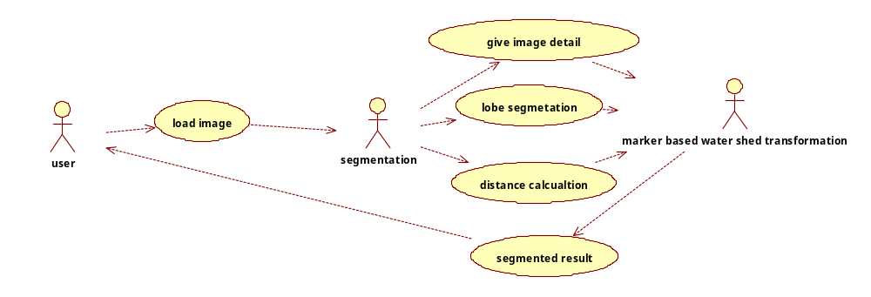

CLASS DIAGRAM
The class diagram is a static diagram. It represents the static view of an application. Class diagram is not only used for visualizing, describing and documenting different aspects of a system but also for constructing executable code of the software application. The class diagram describes the attributes and operations of a class and also the constraints imposed on the system. The class diagrams are widely used in the modeling of object oriented systems because they are the only UML diagrams which can be mapped directly with object oriented languages. The class diagram shows a collection of classes, interfaces, associations, collaborations and constraints. It is also known as a structural diagram.

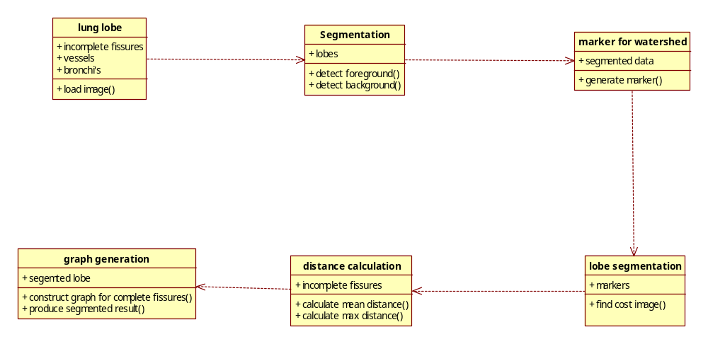

SEQUENCE DIAGRAM
Sequence diagrams describe interactions among classes in terms of an exchange of messages over time. UML sequence diagrams are used to show how objects interact in a given situation. An important characteristic of a sequence diagram is that time passes from top to bottom: the interaction starts near the top of the diagram and ends at the bottom (i.e. Lower equals later). A popular use for them is to document the dynamics in an object-oriented system. For each key collaboration, diagrams are created that show how objects interact in various representative scenarios for that collaboration.

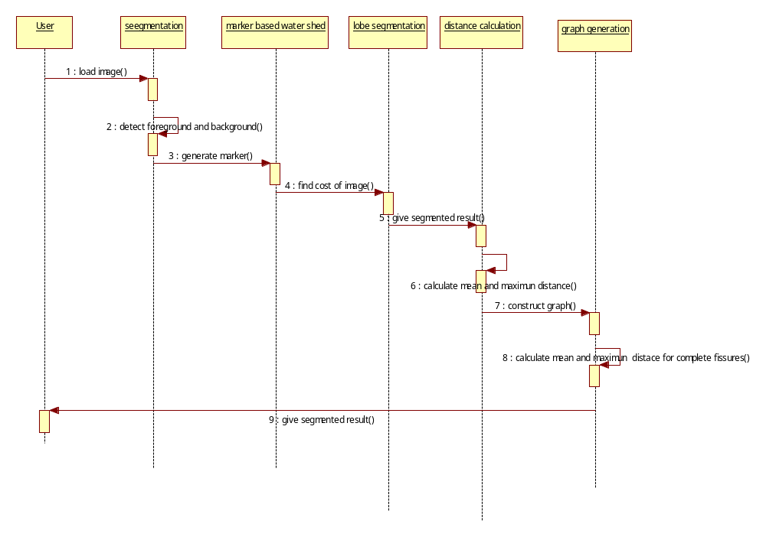

ACTIVITY DIAGRAM
Activity diagrams are graphical representations of workflows of stepwise activities and actions with support for choice, iteration and concurrency. In the Unified Modeling Language, activity diagrams can be used to describe the business and operational step-by-step workflows of components in a system. An activity diagram shows the overall flow of control. Activity diagram is another important diagram in UML to describe dynamic aspects of the system. Activity diagram is basically a flow chart to represent the flow form one activity to another activity. The activity can be described as an operation of the system. So the control flow is drawn from one operation to another. This flow can be sequential, branched or concurrent. Activity diagrams deals with all type of flow control by using different elements like fork, join etc.
The basic purposes of activity diagrams are similar to other four diagrams. It captures the dynamic behavior of the system. Other four diagrams are used to show the message flow from one object to another but activity diagram is used to show message flow from one activity to another. Activity is a particular operation of the system. Activity diagrams are not only used for visualizing dynamic nature of a system but they are also used to construct the executable system by using forward and reverse engineering techniques. The only missing thing in activity diagram is the message part. It does not show any message flow from one activity to another. Activity diagram is some time considered as the flow chart. Although the diagrams looks like a flow chart but it is not. It shows different flow like parallel, branched, concurrent and single.
So the purposes can be described as:
- Draw the activity flow of a system.
- Describe the sequence from one activity to another.
- Describe the parallel, branched and concurrent flow of the system.

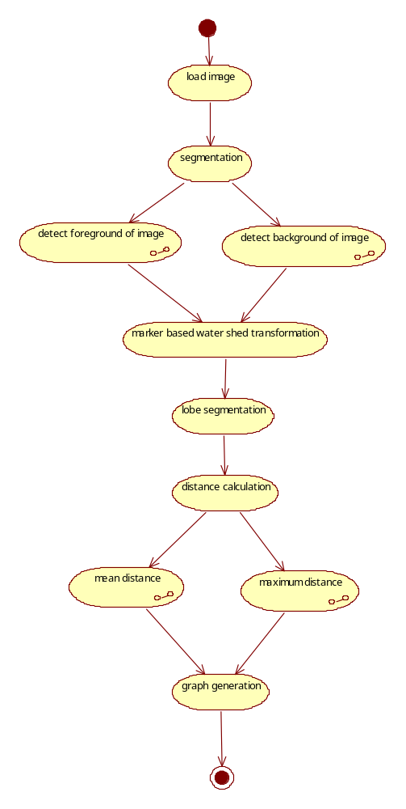
COLLABORATION DIAGRAM
The UML Collaboration diagram is used to model how objects involved in a scenario interact, with each object instantiating a particular class in the system. Objects are connected by links, each link representing an instance of an association between the respective classes involved. The link shows messages sent between the objects, and the type of message passed (synchronous, asynchronous, simple, balking, and timeout). Collaboration diagrams offer a better view of a scenario than a Sequence diagram when the modeler is trying to understand all of the effects on a given object and are therefore good for procedural design.

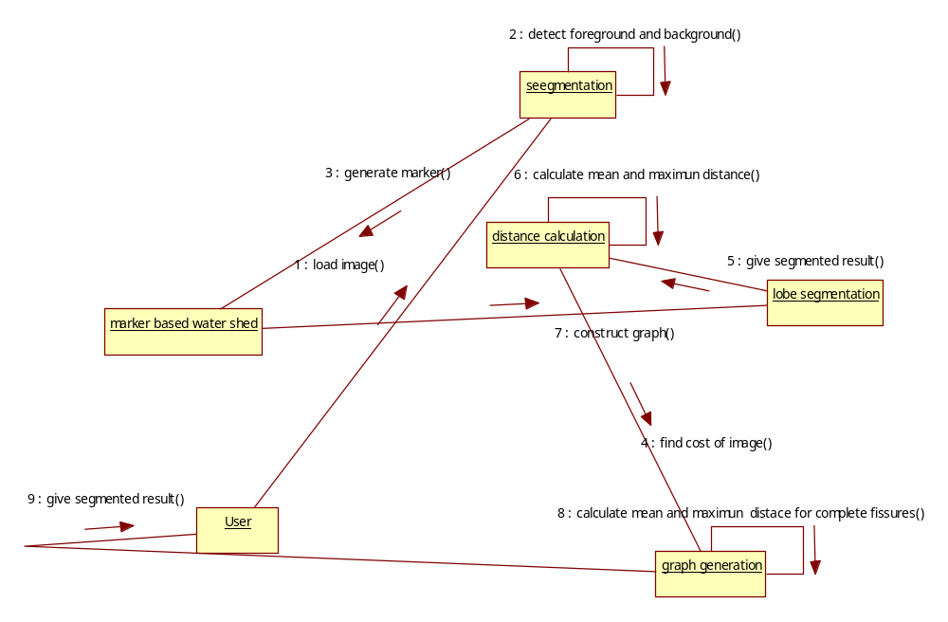

SYSTEM IMPLEMETATION
In our proposed system implement the Marker based watershed Transformation technique to segment the lung lobes otherwise in terms the segmentation on lung lobes use the Marker based watershed transformation technique. The existing system doesn’t segment the incomplete fissures. But, in our Proposed system is against the incomplete or misses fissures. And also our proposed system results are manually checked. They give the 90 percent accurate results. A 3-D region growing algorithm is used to extract the airway lumen from the preprocessed image.

A lobe segmentation method is developed which combines anatomical information from the lungs, vessels, airways, and lobar fissures to obtain the lobes using a watershed-based segmentation method. The method starts by segmenting the lungs, vessels, airways, and fissures, which are later combined into one cost image for the watershed segmentation process. The presented method is implemented in the software development environment.

If we obtain the lobe segmentation on the original resolution, the segmentation results are up sampled using nearest neighbor interpolation. The lobe segmentation against incomplete fissure is most challenging in the segmentation methods. In our proposed system, if we need evaluation result first upload the segmentation results into the system. The two different data sets are used for evaluation. These two data sets are publically available.

Image segmentation is the process of dividing an image into multiple parts. This is typically used to identify objects or other relevant information in digital images. Segmentation could be used for object recognition, occlusion boundary estimation within motion or stereo systems, image compression, image editing, or image database look-up. Image segmentation is useful in many applications. It can identify the regions of interest in a scene or annotate the data. We categorize the existing segmentation algorithm into region-based segmentation, data clustering, watershed segmentation, atlas based segmentation and edge-base segmentation.

FISSURE SEGMENTATION
The human lungs are subdivided into distinct pulmonary lobes separated by thin barriers, called ﬁssures .The right lung consists of an upper, middle, and lower lobe, and where as the left lung consists of only an upper and a lower lobe. Each lobe contains separate supply branches for both vessels and air ways. Segmentation of the pulmonary lobes is relevant in many clinical applications. For example, lobe wise quantiﬁcation of pulmonary parenchyma is useful for diagnosing and monitoring pathologies such as emphysema or ﬁbrosis. Some diseases, such as lung cancer, limited to a single lobe, require resection of a single lobe. In these cases, lung lobe segmentation can support pre-operative planning by providing information about the residual functional parenchyma. Pulmonary lobe segmentation is a challenging task due to the varying image resolution and quality obtained with different CT scanners and acquisition protocols.
Human lungs consist of ﬁve separate lobes, three in the right lung and two in the left. The lobes have individual bronchial and vascular systems and are functioning relatively independent from each other. A robust segmentation of the individual lobes is required for many applications in computer aided diagnostics and intervention. For example, it is clinically important to determine if aﬀections in early stages are conﬁned to single lobes, since the interlobular ﬁssures stem the spread of diseases. Moreover, accurate segmentations are required to characterize and quantify malfunctions like residual pulmonary parenchyma.
Lobe segmentation can be a very challenging task if images lack in quality or if anatomical anomalies occur. Therefore and due to its clinical relevance, a wide variety of approaches has been proposed. Most methods start from a segmentation of the interlobular ﬁssures to separate the lobes. Propose a curve-growing process based on image features and atlas information to segment the ﬁssures. Propose a ﬁssure enhancement based on the eigenvectors of the Hessian, similar to the vesselness measure. Most of these approaches perform well if images are of reasonably good quality. However, a detection of the ﬁssures is often not suﬃcient to separate the lobes because ﬁssures are incomplete for many subjects due to anatomical conditions or severe lung diseases.

SOFTWARE DESCRIPTIONS
MATLAB
Mat lab is a program that was originally designed to simplify the implementation of numerical linear algebra routines. It has since grown into something much bigger, and it is used to implement numerical algorithms for a wide range of applications. The basic language used is very similar to standard linear algebra notation, but there are a few extensions that will likely cause you some problems at first. MATLAB is an interactive program for numerical computation and data visualization; it is used extensively by control engineers for analysis and design. There are many different toolboxes available which extend the basic functions of MATLAB into different application areas; in these tutorials, we will make extensive use of the Control Systems Toolbox. MATLAB is supported on UNIX, Macintosh, and Windows environments; a student version of MATLAB is available for personal computers. For more information on MATLAB, please visit the Math Works link at the top of the page. The idea behind these tutorials is that you can view them in one window while running MATLAB in another window. You should be able to re-do all of the plots and calculations in the tutorials by cutting and pasting text from the tutorials into MATLAB or an m-file.
Mat lab (Matrix laboratory) is an interactive software system for numerical computations and graphics. As the name suggests, Mat lab is especially designed for matrix computations: solving systems of linear equations, computing Eigen values and eigenvectors, factoring matrices, and so forth. In addition, it has a variety of graphical capabilities, and can be extended through programs written in its own programming language. Many such programs come with the system; a number of these extend Mat lab’s capabilities to nonlinear problems, such as the solution of initial value problems for ordinary differential equations.
Mat lab is designed to solve problems numerically, that is, in finite-precision arithmetic. Therefore it produces approximate rather than exact solutions, and should not be confused with a symbolic computation system (SCS) such as Mathematical or Maple. It should be understood that this does not make Mat lab better or worse than an SCS; it is a tool designed for different tasks and is therefore not directly comparable.
The basic data type in Mat lab is an n-dimensional array of double precision numbers. Mat lab 5 differs from earlier versions of Mat lab in that other data types are supported (also in the fact that general, multi-dimensional arrays are supported; in earlier versions, every variable was a two-dimensional array (matrix), with one-dimensional arrays (vectors) and zero-dimensional arrays (scalars) as special cases). The new data types include structures (much like structures in the C programming language--data values are stored in named fields), classes, and ``cell arrays'', which are arrays of possibly different data types (for example, a one-dimensional array whose first entry is a scalar, second entry a string, third entry a vector). I mostly discuss the basic features using n-dimensional arrays, but I briefly discuss the other data types later in the paper.
Mat lab can perform the standard arithmetic operations on matrices, vectors, and scalars (that is, on 2-, 1-, and 0-dimensional arrays): addition, subtraction, and multiplication. In addition, Mat lab defines a notion of matrix division as well as ``vectorized'' operations. All vectorized operations (these include addition, subtraction, and scalar multiplication, as explained below) can be applied to n-dimensional arrays for any value of n, but multiplication and division are restricted to matrices and vectors ( ).
The capabilities of Mat lab can be extended through programs written in its own programming language. It provides the standard constructs, such as loops and conditionals; these constructs can be used interactively to reduce the tedium of repetitive tasks, or collected in programs stored in ``m-files'' (nothing more than a text file with extension ``.m''). A script is simply a collection of Mat lab commands in an m-file (a text file whose name ends in the extension ``.m''). Upon typing the name of the file (without the extension), those commands are executed as if they had been entered at the keyboard. The m-file must be located in one of the directories in which Mat lab automatically looks for m-files; a list of these directories can be obtained by the command path. (See help path to learn how to add a directory to this list.) One of the directories in which Mat lab always looks is the current working directory; the command cd identifies the current working directory, and cd new dir changes the working directory to new dir.

A function implementing the method of bisection illustrates many of the important techniques of programming in Mat lab. The first important technique, without which a useful bisection routine cannot be written, is the ability to pass the name of one function to another function. In this case, bisect needs to know the name of the function whose root it is to find. This name can be passed as a string (the alternative is to ``hard-code'' the name inbisect.m, which means that each time one wants to use bisect with a different function, the file bisect must be modified. This style of programming is to be avoided.).
In addition to solving linear systems (with the backslash operator), Mat lab performs many other matrix computations. Among the most useful is the computation of Eigen values and eigenvectors with the eig command. If A is a square matrix, then ev = eig(A) returns the Eigen values of A in a vector, while [V,D] = eig(A) returns the spectral decomposition of A: V is a matrix whose columns are eigenvectors of A, while D is a diagonal matrix whose diagonal entries are Eigen values. The equation AV = VD holds. If A is diagonalizable, then V is invertible, while if A is symmetric, then V is orthogonal ( ).
Mat lab has the ability to store and manipulate sparse matrices, which greatly increases its usefulness for realistic problems. Creating a sparse matrix can be rather difficult, but manipulating them is easy, since the same operators apply to both sparse and dense matrices. In particular, the backslash operator works with sparse matrices, so sparse systems can be solved in the same fashion as dense systems. Some of the built-in functions apply to sparse matrices, but others do not (for example, eig can be used on sparse symmetric matrix, but not on a sparse non symmetric matrix).
Mat lab can produce several different types of graphs: 2D curves, 3D surfaces, contour plots of 3D surfaces, parametric curves in 2D and 3D. I will leave the reader to find most of the details from the online help system. Here I want to show, by example, some of the possibilities. I will also explain the basics of producing 3D plots. The subplot command creates several plots in a single window. To be precise, sub plot (m, n, i) creates mn plots, arranged in an array with m rows and n columns. It also sets the next plot command to go to the ith coordinate system (counting across the rows).
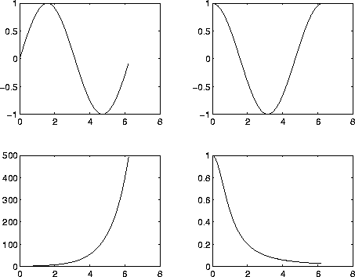

In order to create a graph of a surface in 3-space (or a contour plot of a surface), it is necessary to evaluate the function on a regular rectangular grid. This can be done using the mesh grid command. First, create 1D vector describing the grids in the x- and y-directions:
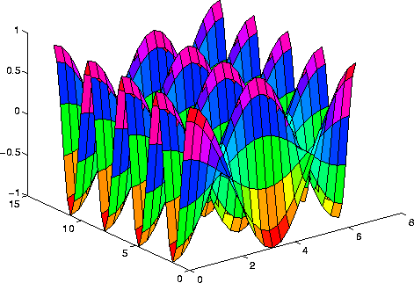
In addition to functions for numerical linear algebra, Mat lab provides functions for the solution of a number of common problems, such as numerical integration, initial value problems in ordinary differential equations, root-finding, and optimization. In addition, optional ``Toolboxes'' provide a variety of such functions aimed at a particular type of computation, for example, optimization, spline approximation, signal processing, and so forth. I will not discuss the optional toolboxes.
More details about the following commands may be obtained from the help command:
- quad, quad8 numerical integration (quadrature);
- ode23, ode45 adaptive methods for initial value problems in ordinary differential equations;
- fzero root-finding (single variable);
- fmin nonlinear minimization (single variable);
- fmins nonlinear minimization (several variables);
- Spline creates a cubic spline interpolant of give data.
In addition to multi-dimensional arrays, Mat lab 5 supports several advanced data types that were not present in earlier versions of Mat lab. Following is a very brief introduction to these types; a detailed description is beyond the scope of this paper. A structure is a data type which contains several values, possibly of different types, referenced by name. The simplest way to create a structure is by simple assignment. A cell array is an array whose entries can be data of any type. The index operator {} is used in place of () to indicate that an array is a cell array instead of an ordinary array. Mat lab 5 now supports the use of classes, which can be thought of structures that contain both data and functions (class methods). (In contrast, a strut contains only data.) One class can be derived from another class (the base class), meaning that it inherits the properties--data and methods--of the base class. Also, Mat lab now supports overloading of functions. Through these mechanisms, Mat lab enables object-oriented design of programs.

FEASIBILITY STUDY
LUNG LOBE SEGMENTATION
These segments each have their own artery. Thus, each broncho pulmonary segment is supplied by a segmental bronchus, and two arteries, a pulmonary artery and a bronchial artery which run together through the center of the segment. Veins and lymphatic’s drain along the edges. There are 10 broncho pulmonary segments in the right lung (3 in superior lobe, 2 in middle lobe, 5 in inferior lobe) and 8-10 segments on the left (4-5 in upper lobe, 4-5 in lower lobe). Each segment is separated from the others by a layer of connective tissue. This means that each broncho pulmonary segment is a discrete anatomical and functional unit, and this separation means that a broncho pulmonary segment can be surgically removed without affecting the function of the other segments.
Here systems apply the marker based watershed transformation. After finding the cost image, this lobe segmentation takes the input of cost image and marker from bronchi tree. The applied watershed algorithm separates regions with local maxima in between and can be used with an arbitrary number of markers. The borders between the obtained lobes after the watershed segmentation are not always smooth due to local variations in the cost image. The label value that occurs most often under the kernel is set to the voxel. To obtain the lobe segmentation on the original resolution, the segmentation results are up sampled using nearest neighbor interpolation.

With the widespread use of computed tomography (CT) and multidetector CT scanners, large volumes of data reconstructed in thin sections can be produced. These capabilities are not fully utilized due to the large amount of data that needs to be analyzed. Therefore, automatic or semi-automatic image analysis systems are being developed to assist radiologists not only in detection but also qualitative and quantitative analysis of lung pathology while minimizing repetitive and tedious aspects of image interpretation. To become reliable and useful clinical tools for chest CT analysis, image-based diagnosis systems must be able to segment and model the lung and its associated structures accurately.

A structure with important implications for the segmentation of local areas within the lung is the pulmonary fissure, a three-dimensional (3D) boundary surface between the lobes of the lung. The left lung has two lobes separated by a major fissure, and the right lung has three lobes separated by one minor, or horizontal, and one major, or oblique, fissure. This paper describes a method for segmenting the major fissure on thin-section CT.
On CT, a fissure can have a variety of appearances, which makes its detection and segmentation challenging. Due to respiratory and cardiac motion, as well as partial volume effect, a fissure often appears as a ribbon-like structure, several pixels wide, rather than the more typical configuration of a thin curvilinear opacity with sharp edges. When the fissure appears as a ribbon structure, it forms locally bright “ridges” in the axial images and its exact width is difficult to determine. Moreover, frequently fissures are incomplete on CT and lobes also have been described to be partially fused. Detection and segmentation of the fissure is further complicated by “clutter”, i.e., structures that are located adjacent to the fissure, such as small vessels or nodules. Lastly, the image may also be affected by noise introduced by the imaging process. Our objective was to develop a fissure segmentation method that is robust, i.e., can handle the range of fissure appearances described above.
The human lungs are subdivided into five lobes that are separated by visceral pleura called pulmonary fissure. There are three lobes in the right lung, namely upper, middle, and lower lobe. The right upper and right middle lobe are divided by the right minor fissure whereas the right major fissure delimits the lower lobe from the rest of the lung. In the left lung there are only two lobes, the upper and the lower lobe, that are divided by the left major fissure. A characteristic of the pulmonary lobes are separated supply branches for both vessels and airways. Lung lobe segmentation is relevant in clinical applications particularly for treatment planning. The location and distribution of pulmonary diseases are important parameters for the selection of a suitable treatment. Locally distributed emphysema can be treated more effective by lobar volume resection than homogeneously distributed emphysema. Another application is quantitative monitoring of pulmonary diseases such as emphysema or fibrosis. A lobe-wise analysis shows the progression of the disease in more detail.

SEGMENTATION
In the analysis of the objects in images it is essential that we can distinguish between the objects of interest and "the rest." This latter group is also referred to as the background. The techniques that are used to find the objects of interest are usually referred to as segmentation techniques segmenting the foreground from background. In this section we will two of the most common techniques thresholding and edge finding and we will present techniques for improving the quality of the segmentation result. It is important to understand that there is no universally applicable segmentation technique that will work for all images, and, no segmentation technique is perfect.
Image segmentation is the process of dividing an image into multiple parts. This is typically used to identify objects or other relevant information in digital images. After a successful segmenting the image, the contours of objects can be extracted using edge detection and/or border following techniques. Shape of objects can be described. Based on shape, texture, and color objects can be identified. Image segmentation techniques are extensively used in similarity searches. The objects can be distinguished by assigning an arbitrary pixel value or average pixel value to the pixels belonging to the same clusters.
The result of image segmentation is a set of segments that collectively cover the entire image, or a set of contours extracted from the image (see edge detection). Each of the pixels in a region is similar with respect to some characteristic or computed property, such as color, intensity, or texture. Adjacent regions are significantly different with respect to the same characteristic(s). When applied to a stack of images, typical in medical imaging, the resulting contours after image segmentation can be used to create 3D reconstructions with the help of interpolation algorithms like marching cubes. At the lowest level is local segmentation, which operates in a purely local manner using only a small number of pixels. At a higher level is global segmentation which attempts to group together related pixels from throughout the image. The highest level is object recognition, whereby global segments are designed to operate on whole image or large portion of the image.

LITERATURE SURVEY
E. van Rikxoort, B. van Ginneken, M. Klik, and M. Prokop, “Supervised enhancement filters: Application to fissure detection in chest CT scans,” IEEE Trans. Med. Imag., vol. 27, no. 1, pp. 1–10, Jan. 2008.
EMPIRE10 (Evaluation of Methods for Pulmonary Image Registration 2010) is a public platform for fair and meaningful comparison of registration algorithms which are applied to a database of intrapatient thoracic CT image pairs. Evaluation of non rigid registration techniques is a nontrivial task. This is com-pounded by the fact that researchers typically test only on their own data, which varies widely. For this reason, reliable assessment and comparison of different registration algorithms has been virtually impossible in the past. In this work we present the results of the launch phase of EMPIRE10, which comprised the comprehensive evaluation and comparison of 20 individual algorithms from leading academic and industrial research groups. All algorithms are applied to the same set of 30 thoracic CT pairs. Algorithm set-tings and parameters are chosen by researcher’s expert in the conﬁguration of their own method and the evaluation is independent, using the same criteria for all participants. All results are published on the EMPIRE10 website (http://empire10.isi.uu.nl). The challenge remains ongoing and open to new participants. Full results from 24 algorithms have been published at the time of writing. This paper details the organization of the challenge, the data and evaluation methods and the outcome of the initial launch with 20algorithms. The gain in knowledge and future work are discussed.

J. Wang, M. Betke, and J. P. Ko, “Pulmonary fissure segmentation on CT,” Med. Image Anal., vol. 10, no. 4, pp. 530–547, 2006.
Lung cancer has become one of the leading causes of death in the world. Clear evidence shows that early discovery, early diagnosis and early treatment of lung cancer can significantly increase the chance of survival for patients. Lung Computer-Aided Diagnosis (CAD) is a potential method to accomplish a range of quantitative tasks such as early cancer and disease detection, In computer-aided diagnosis of lung disease, accurate and fast pulmonary parenchyma segmentation is the core step. Watershed algorithm is used in this paper to segment and extract lung parenchyma. To reduce over-segmentation, an improved watershed segmentation method which marks foreground and background is proposed. This method is based on watershed algorithm using “Sobel” operator on edge detection and then using mathematical morphology opening and closing operations and morphological reconstruction to mark the foreground. Extracting the local maximum associated with object will constitute the binary marker image. By testing different types of images, it proposes that the algorithm in this paper can be consistent with human visual characteristics and get more accurate, continuous object boundary. Compared with other watershed improvement methods, this proposed one requires less computational complexity, more simple parameters, and can effectively reduce over-segmentation.

J. Pu, J. Leader, B. Zheng, F. Knollmann, C. Fuhrman, F. Sciurba, and D. Gur, “A computational geometry approach to automated pulmonary fissure segmentation in CT examinations,” IEEE Trans. Med. Imag., vol. 28, no. 5, pp. 710–719, May 2009.

Identification of pulmonary fissures, which form the boundaries between the lobes in the lungs, may be useful during clinical interpretation of computed tomography (CT) examinations to assess the early presence and characterization of manifestation of several lung diseases. Motivated by the unique nature of the surface shape of pulmonary fissures in 3-D space, we developed a new automated scheme using computational geometry methods to detect and segment fissures depicted on CT images. After a geometric modeling of the lung volume using the marching cubes algorithm, Laplacian smoothing is applied iteratively to enhance pulmonary fissures by depressing non fissure structures while smoothing the surfaces of lung fissures. Next, an extended Gaussian image based procedure is used to locate the fissures in a statistical manner that approximates the fissures using a set of plane ldquopatchesrdquo. This approach has several advantages such as independence of anatomic knowledge of the lung structure except the surface shape of fissures, limited sensitivity to other lung structures, and ease of implementation. The scheme performance was evaluated by two experienced thoracic radiologists using a set of 100 images (slices) randomly selected from 10 screening CT examinations. In this preliminary evaluation 98.7% and 94.9% of scheme segmented fissure voxels are within 2 mm of the fissures marked independently by two radiologists in the testing image dataset. Using the scheme detected fissures as reference, 89.4% and 90.1% of manually marked fissure points have distance les2 mm to the reference suggesting a possible under-segmentation of the scheme.

E. van Rikxoort, J. Goldin, M. Galperin-Aizenberg, F. Abtin, H. Kim, P. Lu, B. van Ginneken, G. Shaw, and M. Brown, “A method for the automatic quantification of the completeness of pulmonary fissures: Evaluation in a database of subjects with severe emphysema,” Eur. Radiol., vol. 22, pp. 302–309, 2012.

To propose and evaluate a technique for automatic quantification of fissure completeness from chest computed tomography (CT) in a database of subjects with severe emphysema. Methods Ninety-six CT studies of patients with severe emphysema were included. The lungs, fissures and lobes were automatically segmented. The completeness of the fissures was calculated as the percentage of the lobar border defined by a fissure. The completeness score of the automatic method was compared with a visual consensus read by three radiologists using box plots, rank sum tests and ROC analysis.

R. Wiemker, T. Buelow, and T. Blaffert, “Unsupervised extraction of the pulmonary interlobar fissures from high resolution thoracic CT data,” Comput. Assist. Radiol. Surg., vol. 1281, pp. 1121–1126, 2005.

This paper describes a framework for establishing a reference airway tree segmentation, which was used to quantitatively evaluate 15 different airway tree extraction algorithms in a standardized manner. Because of the sheer difficulty involved in manually constructing a complete reference standard from scratch, we propose to construct the reference using results from all algorithms that are to be evaluated. We start by subdividing each segmented airway tree into its individual branch segments. Each branch segment is then visually scored by trained observers to determine whether or not it is a correctly segmented part of the airway tree. Finally, the reference airway trees are constructed by taking the union of all correctly extracted branch segments. Fifteen airway tree extraction algorithms from different research groups are evaluated on a diverse set of 20 chest computed tomography (CT) scans of subjects ranging from healthy volunteers to patients with severe pathologies, scanned at different sites, with different CT scanner brands, models, and scanning protocols. Three performance measures covering different aspects of segmentation quality were computed for all participating algorithms. Results from the evaluation showed that no single algorithm could extract more than an average of 74% of the total length of all branches in the reference standard, indicating substantial differences between the algorithms. A fusion scheme that obtained superior results is presented, demonstrating that there is complementary information provided by the different algorithms and there is still room for further improvements in airway

Q.Wei, Y. Hu, J.MacGregor, and G. Gelfand, “Automatic recognition of major fissures in human lungs,” Int. J. Comput. Assist. Radiol. Surg., vol. 7, no. 1, pp. 111–123, 2012.
To propose and evaluate a technique for automatic quantification of fissural completeness from chest computed tomography (CT) in a database of subjects with severe emphysema. Ninety-six CT studies of patients with severe emphysema were included. The lungs, fissures and lobes were automatically segmented. The completeness of the fissures was calculated as the percentage of the lobar border defined by a fissure. The completeness score of the automatic method was compared with a visual consensus read by three radiologists using box plots, rank sum tests and ROC analysis. The consensus read found 49% (47/96), 15% (14/96) and 67% (64/96) of the right major, right minor and left major fissures to be complete. For all fissures visually assessed as being complete the automatic method resulted in significantly higher completeness scores (mean 92.78%) than for those assessed as being partial or absent (mean 77.16%; all p values <0.001). The areas under the curves for the automatic fissural completeness were 0.88, 0.91 and 0.83 for the right major, right minor and left major fissures respectively. An automatic method is able to quantify fissural completeness in a cohort of subjects with severe emphysema consistent with a visual consensus read of three radiologists.

MeVisLab medical image processing and visualization (v2.3) 2011 [Online]. Available: http://www.mevislab.de

In this paper we present one method for segmenting the lungs and three methods to segment pulmonary lobes from thoracic CT images and their application to the LOLA11 challenge data. The lung segmentation procedure is fully automated and uses a sequence of morphological operations to refine an initial threshold-based segmentation of the pulmonary airspaces. Based on its results, lobe segmentation is performed. The three presented lobe segmentation methods differ substantially in grade of automation. The first lobe segmentation method is a fully automatic segmentation algorithm that combines information from lobar, fissures, blood vessels and the airway tree by means of a watershed transformation. The second presented method describes an efficient interactive correction mechanism for existing lobe segmentations. The user can iteratively modify a lobar boundary by drawing its correct course onto regions of insufficient segmentation, getting instant feedback of the results of his actions. The third presented algorithm is an interactive method related to the second one, but it allows for segmentation from scratch based on a lung mask only. Evaluation of the methods was performed as part of the LOLA11 challenge on 55 CT scans that can be considered challenging due to a large number of substantially abnormal cases. Automated lung segmentation took 1 minute on average and the mean overlap with the reference standard was 97.3 %. For the fully automated, interactively corrected, and interactive lobe segmentation, average processing times were below 10 minutes each and the mean overlaps were 88.1 %, 91.8 %, and 92.3 %, respectively.

B. Lassen, J.-M. Kuhnigk, E. M. van Rikxoort, and H.-O. Peitgen, “Interactive lung lobe segmentation and correction in tomographic images,” Proc. SPIE Med. Imag., vol. 7963, p. 79631S, 2011.

Segmentation of the pulmonary lobes is relevant in clinical practice and particularly challenging for cases with severe diseases or incomplete fissures. In this work an automated segmentation approach is presented that performs a marker based watershed transformation on CT scans to subdivide the lungs into lobes. A cost image for the watershed transformation is computed by combining information from fissures, bronchi, and pulmonary vessels. The lobar markers are calculated by an analysis of the automatically labeled bronchial tree. By integration of information from several anatomical structures the segmentation is made robust against incomplete fissures. For evaluation the method was compared to a recently published method on 20 CT scans with no or mild disease. The average distances to the reference segmentation were 0.69 mm, 0.67 mm, and 1.21 mm for the left major, right major, and right minor fissure, respectively. In addition the results were submitted to LOLA11, an international lung lobe segmentation challenge with publically available data including cases with severe diseases. The average distances to the reference for the 55 CT scans provided by LOLA11 were 0.98 mm, 3.97 mm, and 3.09 mm for the left major, right major, and right minor fissure. Moreover, an analysis of the relation between segmentation quality and fissure completeness showed that the method is robust against incomplete fissures.

M. Gülsün, O. Ariyürek, R. Cömert, and N. Karabulut, “Variability of the pulmonary oblique fissures presented by high-resolution computed tomography,” Surg. Radiol. Anat., vol. 28, pp. 293–299, 2006.

Reducing pulmonary volume through implantation of end bronchial valves is a major interest to improve exercise tolerance and survival in patients with severe emphysema. The primary aim of this study was to evaluate how well CT-determined fissure integrity predicts interlobar collateral ventilation. The secondary objective was to show whether there is a relationship between the size of fissural defects and the presence of collateral ventilation. Thirty patients with heterogeneous emphysema (post bronchodilator forced expiratory volume in 1 second [FEV1] = 20–50% predicted and > 50% of emphysema in a lobe) underwent collateral ventilation measurements with a catheter through an occlusive balloon within this target lobe during flexible endoscopy. Two senior thoracic radiologists studied the fissures on thoracic high-resolution CT. Collateral ventilation was successfully measured in 37 target lobes in 25 patients. The fissures surrounding the 37 target lobes were evaluated on CT. For the detection of collateral ventilation, the presence of a fissural defect on CT has a sensitivity, specificity, positive predictive value, and negative predictive value of 95%, 44%, 69%, and 88%, respectively. There was a statistically significant difference in the area of the defect between patients with collateral ventilation and those without collateral ventilation (p = 0.04). Analysis of pulmonary fissures using CT is useful before endoscopic volume reduction because results are well correlated to endoscopic measurements of collateral ventilation. Further study with clinical outcomes is mandatory to determine if and when one test or the other or both should be used in patient selection.

J.-M. Kuhnigk, V. Dicken, S. Zidowitz, L. Bornemann, B. Kuemmerlen, S. Krass, H.-O. Peitgen, S. Yuval, H.-H. Jend, W. S. Rau, and T. Achenbach, “New tools for computer assistance in thoracic CT—Part I: Functional analysis of lungs, lung lobes, and broncho pulmonary segments,” Radio Graphics, vol. 25, no. 2, pp. 525–536, 2005.

Computed tomography (CT) imaging is the modality of choice for lung cancer diagnostics. With the increasing number of lung interventions on sub lobar level in recent years, determining and visualizing pulmonary segments in CT images and, in oncological cases, reliable segment-related information about the location of tumors has become increasingly desirable. Computer-assisted identification of lung segments in CT images is subject of this work. The authors present a new interactive approach for the segmentation of lung segments that uses the Euclidean distance of each point in the lung to the segmental branches of the pulmonary artery. The aim is to analyze the potential of the method. Detailed manual pulmonary artery segmentations are used to achieve the best possible segment approximation results. A detailed description of the method and its evaluation on 11 CT scans from clinical routine are given. An accuracy of 2–3 mm is measured for the segment boundaries computed by the pulmonary artery-based method. On average, maximum deviations of 8 mm are observed. 135 inter segmental pulmonary veins detected in the 11 test CT scans serve as reference data. Furthermore, a comparison of the presented pulmonary artery-based approach to a similar approach that uses the Euclidean distance to the segmental branches of the bronchial tree is presented. It shows a significantly higher accuracy for the pulmonary artery-based approach in lung regions at least 30 mm distal to the lung hilum. A pulmonary artery-based determination of lung segments in CT images is promising. In the tests, the pulmonary artery-based determination has been shown to be superior to the bronchial tree-based determination. The suitability of the segment approximation method for application in the planning of segment resections in clinical practice has already been verified in experimental cases. However, automation of the method accompanied by an evaluation on a larger number of test cases is required before application in the daily clinical routine.

S. Ukil and J. M. Reinhardt, “Anatomy-guided lung lobe segmentation in x-ray CT images,” IEEE Trans. Med. Imag., vol. 28, no. 2, pp. 202–214, Feb. 2009.

The human lungs are divided into five distinct anatomic compartments called the lobes, which are separated by the pulmonary fissures. The accurate identification of the fissures is of increasing importance in the early detection of pathologies, and in the regional functional analysis of the lungs. We have developed an automatic method for the segmentation and analysis of the fissures, based on the information provided by the segmentation and analysis of the airway and vascular trees. This information is used to provide a close initial approximation to the fissures, using a watershed transform on a distance map of the vasculature. In a further refinement step, this estimate is used to construct a region of interest (ROI) encompassing the fissures. The ROI is enhanced using a ridgeness measure, which is followed by a 3-D graph search to find the optimal surface within the ROI. We have also developed an automatic method to detect incomplete fissures, using a fast-marching based segmentation of a projection of the optimal surface. The detected incomplete fissure is used to extrapolate and smoothly complete the fissure. We evaluate the method by testing on data sets from normal subjects and subjects with mild to moderate emphysema.

L. Zhang, E. A. Hoffman, and J. M. Reinhardt, “Atlas-driven lung lobe segmentation in volumetric X-ray CT images,” IEEE Trans. Med. Imag., vol. 25, no. 1, pp. 1–16, Jan. 2006.

Medical imaging is the technique that is used to create images of the human body or parts for clinical purposes (medical procedures seeking to reveal diagnose or examine disease). The CT images provide detailed information of anatomy of lungs, which could be used for better surgical planning of treating Lung Cancer This Work, proposes a method for Segmentation of Lung lobes and fissures for surgical planning of treating Lung Cancer. This work presents a 'lobe and fissure' segmentation algorithm that uses a two stage approach. This work presents a threshold based lobe segmentation algorithm. Modified adaptive fissure sweeping and Wavelet Transform are used to segment Lung fissures in CT images. The unseen or partially seen fissures are enhanced and segmented. The main modules of this work are Preprocessing, Lung Segmentation by Iterative Threshold method, Fissure Region Sweeping, Wavelet Transform, Otsu's binarization, Fissure verification, Interpolation and Extension of Fissures. In the Preprocessing work noises are reduced. The preprocessing is done by fuzzy filter. In the next module lung area are segmented by Iterative Threshold Method. Then the fissure regions are collected. Next Wavelet Transform generates the features. Then Otsu's method is adopted for binarization. Next Interpolation is done and fissure is extended up to needed length. Finally Fissure information are extracted and displayed.

J. C. Ross, R. San Jose Washko, A. Diaz, C.-F Westin, R. Kikinis, E. K. Silverman, and G. R.Washko, “Lung extraction, lobe segmentation and hierarchical region assessment for quantitative analysis on high resolution computed tomography images,” in MICCAI. : 2009, vol. 5762, LNCS, pp. 690–698.

Automated extraction of pulmonary anatomy provides a foundation for computerized analysis of computed tomography (CT) scans of the chest. A completely automatic method is presented to segment the lungs, lobes and pulmonary segments from volumetric CT chest scans. The method starts with lung segmentation based on region growing and standard image processing techniques. Next, the pulmonary fissures are extracted by a supervised filter. Subsequently the lung lobes are obtained by voxel classification where the position of voxels in the lung and relative to the fissures is used as features. Finally, each lobe is subdivided in its pulmonary segments by applying another voxel classification that employs features based on the detected fissures and the relative position of voxels in the lobe. The method was evaluated on 100 low-dose CT scans obtained from a lung cancer screening trial and compared to estimates of both inter observer and intra observer agreement. The method was able to segment the pulmonary segments with high accuracy (77%), comparable to both inter observer and intra observer accuracy (74% and 80%, respectively).

J.C.Ross,R. San Jose Estepar, G. Kindlmann, A. Diaz,C.-FWestin, E. K. Silverman, and G. R. Washko, “Automatic lung lobe segmentation using particles, thin plate splines, and maximum a posteriori estimation,” in MICCAI. New York: Springer, 2010, vol. 6363, LNCS, pp. 163–171.

The relationship between chronic obstructive pulmonary disease (COPD) and atherosclerosis has been suggested; this association may relate to systemic inflammation and endothelial dysfunction, which can lead to alteration of small pulmonary vessels. The relationship between atherosclerosis and small pulmonary vessel alteration, however, has not been assessed in COPD patients. We tested the hypothesis that the severity of thoracic aortic calcification measured by computed tomography (CT) would be associated with the total cross-sectional area of small pulmonary vessels (CSA) on CT images. The study was approved by the institutional review board and was Health Insurance Portability and Accountability Act-compliant. Informed consent was waived. For 51 COPD patients enrolled in the National Heart, Lung, and Blood Institute Lung Tissue Research Consortium, we calculated the percentage of total CSAs of less than 5 mm(2) for the total lung area (%CSA<5). Thoracic aortic calcification, quantified by modified Agatston score, was measured. The correlations between thoracic aortic calcification score and %CSA<5, pulmonary function, and extent of emphysema were evaluated. Multiple linear regression analysis using aortic calcification score as the dependent outcome was also performed. The %CSA<5 had a significant negative correlation with the thoracic aortic calcification score (r = -0.566, P < .0001). Multiple linear regression analysis showed significant correlation between the aortic calcification score and %CSA<5 (P < .0001) independent of age, pack-years, extent of emphysema, and FEV1%. Atherosclerosis, assessed by aortic calcification, is associated with the small pulmonary vascular alteration in COPD. Systemic inflammation and endothelial dysfunction may cause the close relationship between atherosclerosis and small pulmonary vessel alteration.

CONCLUSION
In our proposed system use the marker based water shed transformation technique to segment the lung loges. This is against an incomplete fissure’s. Incomplete fissure segmentation is a challenging one in lobe segmentation. Our proposed system automatically segments the lobes using the marker base water shed algorithm. First we have to load the image into the system. First, it detects the foreground and the background of the image. After that apply the water shed algorithm. The results from this algorithm we are going to segment the lobes. The distances are calculated between the incomplete fissures.
The distance is mean and maximum distance. And finally we construct a one graph which contains the distance between incomplete and complete fissure details. The evaluation is done on same dataset and publically available data. Finally, we have presented a fast automatic lobar segmentation method and shown in an extensive series of experiments with 75 CT scans that the method performs well and is robust against missing fissures.

REFERENCES

1. M. Gülsün, O. Ariyürek, R. Cömert, and N. Karabulut, “Variability of the pulmonary oblique fissures presented by high-resolution computed tomography,” Surg. Radiol. Anat., vol. 28, pp. 293–299, 2006.
2. LOLA11 2011 [Online]. Available: http://lola11.com/
3. E. van Rikxoort, B. van Ginneken, M. Klik, and M. Prokop, “Supervised enhancement filters: Application to fissure detection in chest CT Scans,” IEEE Trans. Med. Imag., vol. 27, no. 1, pp. 1–10, Jan. 2008.
4. R. Wiemker, T. Buelow, and T. Blaffert, “Unsupervised extraction of the pulmonary inter lobar fissures from high resolution thoracic CT Data,” Compute. Assist. Radiol. Surg., vol. 1281, pp. 1121–1126, 2005.
5. J. Wang, M. Betke, and J. P. Ko, “Pulmonary fissure segmentation on CT,” Med. Image Anal., vol. 10, no. 4, pp. 530–547, 2006.
6. J. Pu, J. Leader, B. Zheng, F. Knollmann, C. Fuhrman, F. Sciurba, and D. Gur, “A computational geometry approach to automate pulmonary Fissure segmentation in CT examinations,” IEEE Trans. Med. Imag., vol. 28, no. 5, pp. 710–719, May 2009.
7. Q.Wei, Y. Hu, J.MacGregor, and G. Gelfand, “Automatic recognition of major fissures in human lungs,” Int. J. Compute. Assist. Radiol. Surg., vol. 7, no. 1, pp. 111–123, 2012.
8. E. M. van Rikxoort, B. de Hoop, S. van de Vorst, M. Prokop, and B. van Ginneken, “Automatic segmentation of pulmonary segments from volumetric chest CT scans,” IEEE Trans. Med. Imag., vol. 28, no. 4, pp. 621–630, Apr. 2009.
9. E. van Rikxoort, M. Prokop, B. de Hoop, M. Viergever, J. Pluim, and B. van Ginneken, “Automatic segmentation of pulmonary lobes robust against incomplete fissures,” IEEE Trans. Med. Imag., vol. 29, no. 6, pp. 1286–1296, Jun. 2010.
10. N. Sverzellati, E. Calabro, G. Randi, C. La Vecchia, A. Marchiano, J.-M. Kuhnigk, M. Zompatori, P. Spagnolo, and U. Pastorino, “Sex differences in emphysema phenotype in smokers without airflow obstruction,” Eur. Respirat. J., vol. 33, no. 6, pp. 1320–1328, 2009.

11. S. Ukil and J. M. Reinhardt, “Anatomy-guided lung lobe segmentation in x-ray CT images,” IEEE Trans. Med. Imag., vol. 28, no. 2, pp. 202–214, Feb. 2009.
12. L. Zhang, E. A. Hoffman, and J. M. Reinhardt, “Atlas-driven lung lobe segmentation in volumetric X-ray CT images,” IEEE Trans. Med. Imag., vol. 25, no. 1, pp. 1–16, Jan. 2006.
13. J. Pu, B. Zheng, J. Leader, C. Fuhrman, F. Knollmann, A. Klym, and D. Gur, “Pulmonary lobe segmentation in CT examinations using implicit surface fitting,” IEEE Trans. Med. Imag., vol. 28, no. 12, pp. 1986–1996, Dec. 2009.
14. K.Mori, Y. Nakada, T. Kitasaka, Y. Suenaga, H. Takabatake,M.Mori, and H. Natori, “Lung lobe and segmental lobe extraction from 3-D chest CT datasets based on figure decomposition and voronoi division,” Proc. SPIE Med. Imag., vol. 6914, 2008.
15. J. C. Ross, R. San Jose Washko, A. Diaz, C.-F Westin, R. Kikinis, E. K. Silverman, and G. R.Washko, “Lung extraction, lobe segmentation and hierarchical region assessment for quantitative analysis on high resolution computed tomography images,” in MICCAI. : , 2009, vol. 5762, LNCS, pp. 690–698.
16. J.C.Ross,R. San Jose Estepar, G. Kindlmann, A. Diaz,C.-FWestin, E. K. Silverman, and G. R. Washko, “Automatic lung lobe segmentation using particles, thin plate splines, and maximum a posteriori estimation,” in MICCAI. New York: Springer, 2010, vol. 6363, LNCS, pp. 163–171.
17. B. Lassen, J.-M. Kuhnigk, E. M. van Rikxoort, and H.-O. Peitgen, “Interactive lung lobe segmentation and correction in tomographic images,” Proc. SPIE Med. Imag., vol. 7963, p. 79631S, 2011.
18. B. Lassen, J.-M. Kuhnigk, O. Friman, S. Krass, and H.-O. Peitgen, “Automatic segmentation of lung lobes in CT images based on fissures, vessels, and bronchi,” Proc. Int. Symp. Biomed. Imag. pp. 560–563, 2010.
19. B. Lassen, J.-M. Kuhnigk, M. Schmidt, S. Krass, and H.-O. Peitgen, “Lung and lung lobe segmentation methods at fraunhofer mevis,” presented at the 4th Int. MICCAI Workshop Pulmonary Image Anal., Toronto, Canada, Sep. 2011.
20. Proc. 4th Int. MICCAI Workshop Pulmonary Image Anal R. Beichel and M. de Bruijne, Eds., B. van Ginneken, S. Kabus, A. Kiraly, J.-M. Kuhnigk, J. McClelland,, K. Mori, E. van Rikxoort, and S. Rit, Eds. Toronto, Canada, Sep. 2011

FUTURE ENHANCEMENT

In future, introduce the new Cellular Automata Technique to segment the lung lobes against the incomplete fissures. It’s an advanced concept of the Cellular Automata. This new concept reduces the complexity of the project with compared to the Cellular Automata. And also we construct a fast and intuitive correction of a given segmentation result.

